**BCS Kindergarten School Supplies List**

*The following supplies are needed for the first day of school:

• 1 24 Pack of Crayola Crayons

• 1 Pkg of Beginners Pencils (Ticonderoga #2 HB)

1 Package of 10 Page Protectors

• 2 Large Glue Sticks

• 1 Bottle of White Liquid Glue

• 1 Duo-Tang with inside pockets

• 5 Duo-Tangs (1 Red, 1 Blue, 1 Green, 1 Yellow, 1 Orange -please try to purchase these colors as we color code according to subject.)

• 1 Pair of Headphones

• Hilroy Exercise Book (Half plain, half dotted interlined, 72 pages)

• A Courier Bag (These can be found at the Dollarama)

* Hilroy Studio Scrap Book (Ex. Durable manila paper, 30 sheets)
* 1 Pair of Work/Gardening Gloves
* 1 Water Bottle
* A Book Bag
* Lunch Box or Bag
* A Pair of Inside Sneakers (We recommend Velcro so your child will have some independence.)

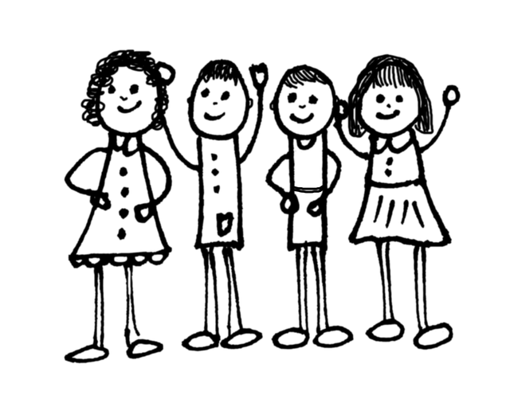

**SCHOOL SUPPLY LIST 2023-2024**

**Kindergarten**